|  |
| --- |
|  |
| The Documentation |
| [Type the document subtitle] |
|  |
| **[Your Name]** |
| **[Pick the date]** |

[Type the abstract of the document here. The abstract is typically a short summary of the contents of the document. Type the abstract of the document here. The abstract is typically a short summary of the contents of the document.]

Table of Contents

[To update the table of contents, right click the message below and select Update Field (F9 on PC, ⌥⌘U on Mac).]

**No table of contents entries found.**

1. Pages
   1. Page Tree

Home  
 Page 1  
 文章  
 文章2  
 Page 2  
 Page 3  
settings  
Classification  
 New Page 1  
 Favorites

* 1. Home
     1. User Interface

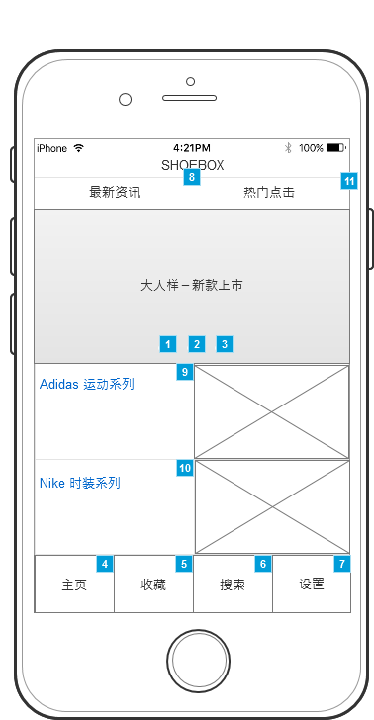

* + 1. Widget Table

| Footnote | Interactions |
| --- | --- |
| 1 | OnClick:  Case 1:  Set is selected of (Flow Shape) equal to "true"  Set (Dynamic Panel) to State1 fade out 500ms slide left in 500ms |
| 2 | OnClick:  Case 1:  Set is selected of (Flow Shape) equal to "true"  Set (Dynamic Panel) to State2 fade out 500ms slide left in 500ms |
| 3 | OnClick:  Case 1:  Set is selected of (Flow Shape) equal to "true"  Set (Dynamic Panel) to State3 fade out 500ms slide left in 500ms |
| 4 | OnClick:  Case 1:  Open Reload in Current Window |
| 5 | OnClick:  Case 1:  Open Favorites in Current Window  Open Reload in Current Window |
| 6 | OnClick:  Case 1:  Open Classification in Current Window |
| 7 | OnClick:  Case 1:  Open settings in Current Window |
| 8 | OnClick:  Case 1:  Open Page 1 in Current Window |
| 9 | OnClick:  Case 1:  Open 文章 in Current Window |
| 10 | OnClick:  Case 1:  Open 文章2 in Current Window |
| 11 | OnClick:  Case 1:  Open Page 2 in Current Window |

* + 1. Unnamed
       1. State1
       2. User Interface

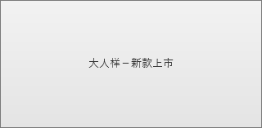

* + - 1. State3
      2. User Interface

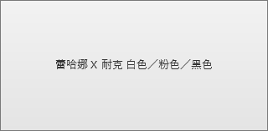

* + - 1. State2
      2. User Interface

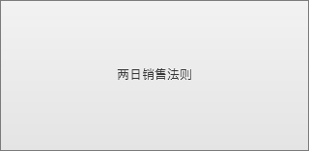

* 1. Page 1
     1. User Interface

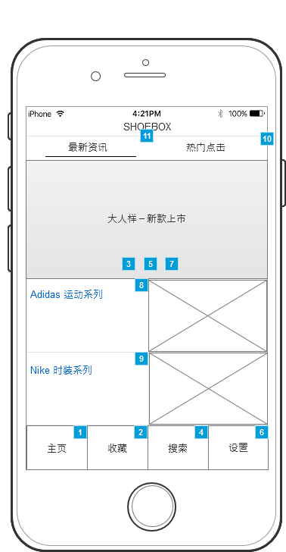

* + 1. Widget Table

| Footnote | Interactions |
| --- | --- |
| 1 | OnClick:  Case 1:  Open Reload in Current Window |
| 2 | OnClick:  Case 1:  Open Favorites in Current Window  Open Reload in Current Window |
| 3 | OnClick:  Case 1:  Set is selected of (Flow Shape) equal to "true"  Set (Dynamic Panel) to State1 fade out 500ms slide left in 500ms |
| 4 | OnClick:  Case 1:  Open Classification in Current Window |
| 5 | OnClick:  Case 1:  Set is selected of (Flow Shape) equal to "true"  Set (Dynamic Panel) to State2 fade out 500ms slide left in 500ms |
| 6 | OnClick:  Case 1:  Open settings in Current Window |
| 7 | OnClick:  Case 1:  Set is selected of (Flow Shape) equal to "true"  Set (Dynamic Panel) to State3 fade out 500ms slide left in 500ms |
| 8 | OnClick:  Case 1:  Open 文章 in Current Window |
| 9 | OnClick:  Case 1:  Open 文章2 in Current Window |
| 10 | OnClick:  Case 1:  Open Page 2 in Current Window |
| 11 | OnClick:  Case 1:  Open Page 1 in Current Window |

* + 1. Unnamed
       1. State1
       2. User Interface



* + - 1. State3
      2. User Interface



* + - 1. State2
      2. User Interface



* 1. 文章
     1. User Interface

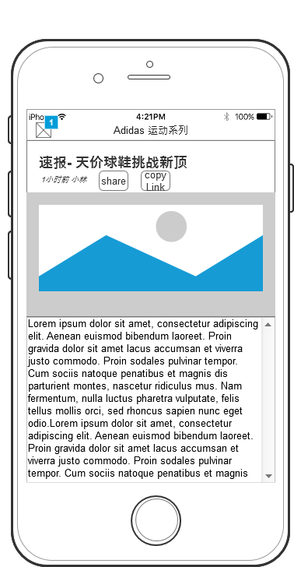

* + 1. Widget Table

| Footnote | Interactions |
| --- | --- |
| 1 | OnClick:  Case 1:  Open Home in Current Window |

* 1. 文章2
     1. User Interface

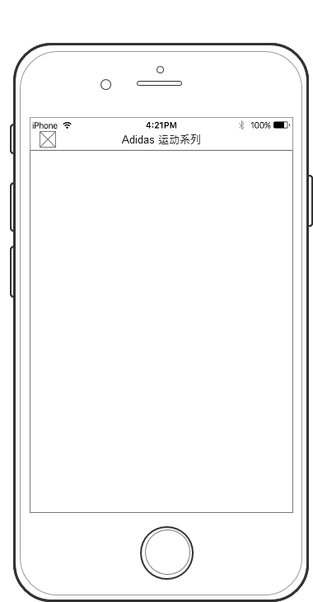

* 1. Page 2
     1. User Interface

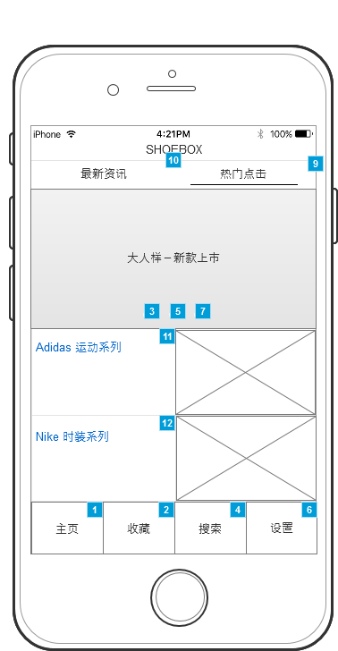

* + 1. Widget Table

| Footnote | Interactions |
| --- | --- |
| 1 | OnClick:  Case 1:  Open Reload in Current Window |
| 2 | OnClick:  Case 1:  Open Favorites in Current Window  Open Reload in Current Window |
| 3 | OnClick:  Case 1:  Set is selected of (Flow Shape) equal to "true"  Set (Dynamic Panel) to State1 fade out 500ms slide left in 500ms |
| 4 | OnClick:  Case 1:  Open Classification in Current Window |
| 5 | OnClick:  Case 1:  Set is selected of (Flow Shape) equal to "true"  Set (Dynamic Panel) to State2 fade out 500ms slide left in 500ms |
| 6 | OnClick:  Case 1:  Open settings in Current Window |
| 7 | OnClick:  Case 1:  Set is selected of (Flow Shape) equal to "true"  Set (Dynamic Panel) to State3 fade out 500ms slide left in 500ms |
| 8 | OnClick:  Case 1:  Open Page 1 in Current Window |
| 9 | OnClick:  Case 1:  Open Page 2 in Current Window |
| 10 | OnClick:  Case 1:  Open Page 1 in Current Window |
| 11 | OnClick:  Case 1:  Open 文章 in Current Window |
| 12 | OnClick:  Case 1:  Open 文章2 in Current Window |

* + 1. Unnamed
       1. State1
       2. User Interface



* + - 1. State3
      2. User Interface



* + - 1. State2
      2. User Interface



* 1. Page 3
     1. User Interface

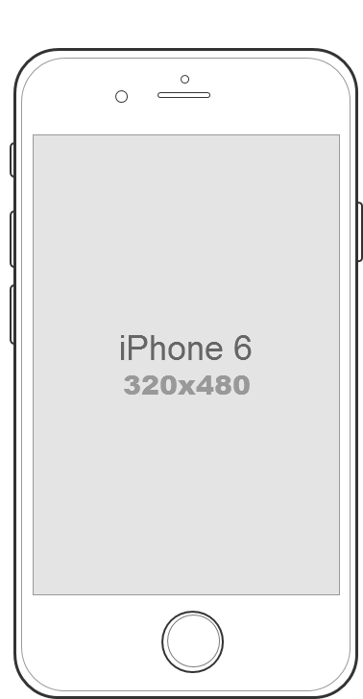

* 1. settings
     1. User Interface

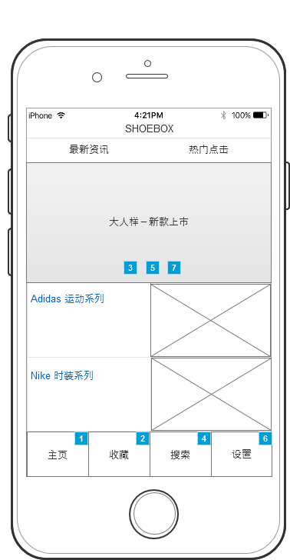

* + 1. Widget Table

| Footnote | Interactions |
| --- | --- |
| 1 | OnClick:  Case 1:  Open Reload in Current Window |
| 2 | OnClick:  Case 1:  Open Favorites in Current Window  Open Reload in Current Window |
| 3 | OnClick:  Case 1:  Set is selected of (Flow Shape) equal to "true"  Set (Dynamic Panel) to State1 fade out 500ms slide left in 500ms |
| 4 | OnClick:  Case 1:  Open Classification in Current Window |
| 5 | OnClick:  Case 1:  Set is selected of (Flow Shape) equal to "true"  Set (Dynamic Panel) to State2 fade out 500ms slide left in 500ms |
| 6 | OnClick:  Case 1:  Open settings in Current Window |
| 7 | OnClick:  Case 1:  Set is selected of (Flow Shape) equal to "true"  Set (Dynamic Panel) to State3 fade out 500ms slide left in 500ms |

* + 1. Unnamed
       1. State1
       2. User Interface



* + - 1. State3
      2. User Interface



* + - 1. State2
      2. User Interface



* 1. Classification
     1. User Interface



* + 1. Widget Table

| Footnote | Interactions |
| --- | --- |
| 1 | OnClick:  Case 1:  Open Reload in Current Window |
| 2 | OnClick:  Case 1:  Open Favorites in Current Window  Open Reload in Current Window |
| 3 | OnClick:  Case 1:  Set is selected of (Flow Shape) equal to "true"  Set (Dynamic Panel) to State1 fade out 500ms slide left in 500ms |
| 4 | OnClick:  Case 1:  Open Classification in Current Window |
| 5 | OnClick:  Case 1:  Set is selected of (Flow Shape) equal to "true"  Set (Dynamic Panel) to State2 fade out 500ms slide left in 500ms |
| 6 | OnClick:  Case 1:  Open settings in Current Window |
| 7 | OnClick:  Case 1:  Set is selected of (Flow Shape) equal to "true"  Set (Dynamic Panel) to State3 fade out 500ms slide left in 500ms |

* + 1. Unnamed
       1. State1
       2. User Interface



* + - 1. State3
      2. User Interface



* + - 1. State2
      2. User Interface



* 1. New Page 1
  2. Favorites
     1. User Interface

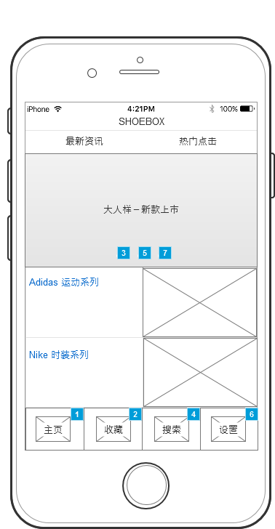

* + 1. Widget Table

| Footnote | Interactions |
| --- | --- |
| 1 | OnClick:  Case 1:  Open Reload in Current Window |
| 2 | OnClick:  Case 1:  Open Favorites in Current Window  Open Reload in Current Window |
| 3 | OnClick:  Case 1:  Set is selected of (Flow Shape) equal to "true"  Set (Dynamic Panel) to State1 fade out 500ms slide left in 500ms |
| 4 | OnClick:  Case 1:  Open Classification in Current Window |
| 5 | OnClick:  Case 1:  Set is selected of (Flow Shape) equal to "true"  Set (Dynamic Panel) to State2 fade out 500ms slide left in 500ms |
| 6 | OnClick:  Case 1:  Open settings in Current Window |
| 7 | OnClick:  Case 1:  Set is selected of (Flow Shape) equal to "true"  Set (Dynamic Panel) to State3 fade out 500ms slide left in 500ms |

* + 1. Unnamed
       1. State1
       2. User Interface



* + - 1. State3
      2. User Interface



* + - 1. State2
      2. User Interface

